**NATIONAL INSTITUTE OF TECHNOLOGY KARNATAKA SURATHKAL**

**DEPARTMENT OF INFORMATION TECHNOLOGY**

**IT 301 Parallel Computing**

**14th September 2021**

**Lab 6**

**NAME: BHUVANESWAR D**

**ROLL NO: 191IT107**

----------------------------------------------------------------------------------------------------------------------

(1) Execute following code and observe the working of task directive.

Check the result by removing if() clause with task. [ 1+1 = 2 Marks]

#include<stdio.h>

#include<omp.h>

int fibo(int n);

int main(void)

{

int n,fib;

double t1,t2;

printf("Enter the value of n:\n");

scanf("%d",&n);

t1=omp_get_wtime();

#pragma omp parallel shared(n)

{

#pragma omp single

{

fib=fibo(n);

}

}

t2=omp_get_wtime();

printf("Fib is %d\n",fib);

printf("Time taken is %f s \n",t2-t1);

return 0;

}

int fibo(int n)

{

int a,b;

if(n<2)

return n;

else

{

#pragma omp task shared(a) if(n>5)

{

printf("Task Created by Thread %d\n",omp_get_thread_num());

a=fibo(n-1);

printf("Task Executed by Thread %d \ta=%d\n",omp_get_thread_num(),a);

}

#pragma omp task shared(b) if(n>5)

{

printf("Task Created by Thread %d\n",omp_get_thread_num());

b=fibo(n-2);

printf("Task Executed by Thread %d \tb=%d\n",omp_get_thread_num(),b);

}

#pragma omp taskwait

return a+b;

}

**WITH IF CLAUSE**

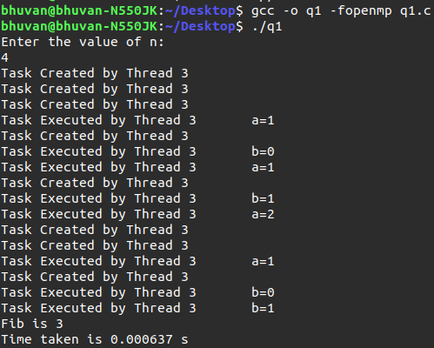

**WITHOUT IF CLAUSE**

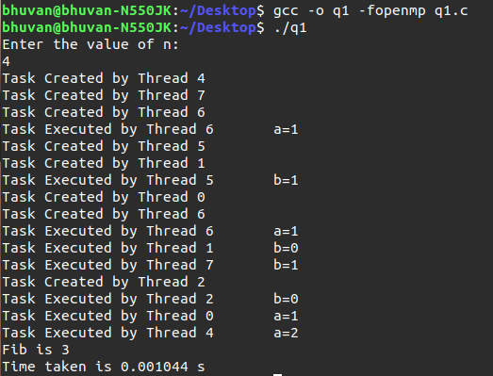

**EXPLAINATION:Task scheduling is done for values n<4 with if() clause. But without if() clause it is done for all values.**

(2) Design a parallel program to find a given element in an unsorted array using Binary Search. Take a large number of elements up to the maximum possible size. Make use of openmp task directive. Use random function to initialise values.

Compare the time taken for searching an element in best case , worst case and average case.

(i) Sequential Binary Search program **[3 Marks]**

(ii) parallel binary search program **[5 Marks]**

**BEST CASE**

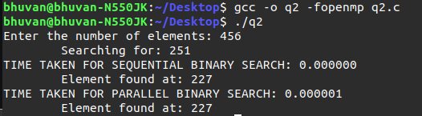

**WORST CASE**

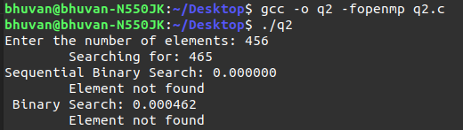

**AVERAGE CASE**

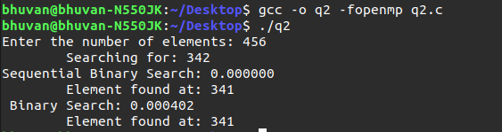

**EXPLAINATION:**

**Sequential execution is faster than parallel since the thread operations are executed in parallel.**

**CODE**



